

Towards Better Data Imputation with Machine Learning



[Date]

[Company name]

[Company address]

Table of Contents

Abstract: 3

Introduction: 3

Background: 7

Imputation to substitute missing values: 7

Methods of data level: 7

Imputation of Mean/Mode: 7

K-nearest neighbour charging (K-NN): 8

Imputing many chained equations (MICE): 8

MissForest: 9

The technique of synthetic minority over-sampling (SMOTE): 10

Synthetic overview: 11

Aims and Objective: 11

Research Questions 12

Ethical Considerations 12

Literature Review 12

Imputation techniques: 16

K-NN Imputation: 16

MissForest: 16

Mixed Data Factorial Analysis (FAMD): 16

Transformation of Z-score: 16

K means, K-means++ and silhouette and oversampling on a cluster basis: 17

Support Vector Machine Parameters: 17

Assessment methods and statistical tests: 17

Accuracy: 17

F-measurement: 18

Project Timeline 19

Project overview and Methodology: 19

Previous comparative outcomes of study and imputation: 20

Classification impact of missing data imputation strategies: 22

Experimentation: 22

Dataset 22

Data Preprocessing and Visualization 23

Machine Learning 25

Results 26

Conclusion and Discussion: 26

Missing Data Imputation Applications: 27

Future Considerations: 27

Reference: 28

# Table of Figures

Figure 1 - Multiple imputations by Chained Equations scheme. 9

Figure 2 - FAMD method (Josse and Husson, 2016) 10

Figure 3 - Literature Review Workflow 12

Figure 4 - Randomized Data Imputation Results from Listwise Deletion, PMM and Poisson Imputation 14

Figure 5 - Results of the Wine Dataset 14

Figure 6 - Results on the Glass Dataset 15

Figure 7 - Results of the Concrete Compressive Strength Dataset 15

Figure 8 - Results of the Liver Patient Dataset 15

Figure 9 - Results on the Seeds Dataset 15

Figure 24 - Normal Q-Q plots. Left: Since the points lie roughly on the y = x line, normality is a reasonable assumption. 16

Figure 10 - Project Timeline 19

Figure 11 - Left-hand side shows possible separating hyperplanes. The right-hand side shows the hyperplane with maximal margin. (James et al., 2000) 19

Figure 12 - Left-hand side: Decision boundary with a polynomial kernel. Right-hand side: Decision boundary. (James et al., 2000) 20

Figure 13 - Mixed-type data. Average NRMSE (left bar) and PFC (right bar), for KNN-Imputation (grey), MICE (white) and missForest(black). On four different datasets and three different amounts of missingness. (Stekhoven and Bühlmann, 2012) 20

Figure 14 - Average runtimes (in seconds) for imputing the datasets analyzed by (Stekhoven and Bühlmann, 2012) 21

Figure 15 - Distribution of the NRMSE (left) and the PFC (right) when the relationships between variables are linear for different amounts of missing values (10, 20, 30 %). White boxplots correspond to the imputation error for the algorithm based on random forest. (Audigier, Husson and Josse, 2013) 21

Figure 16 - Distribution of the NRMSE (left) and the PFC (right) when there are interactions between variables. (Audigier, Husson and Josse, 2013) 22

Figure 17 - Dataset Features and their Description 23

Figure 18 - The number of missing values in "Age" and "Cabin" in both datasets. 23

Figure 19 - Probability Distribution comparison for features in the training and test datasets. 24

Figure 20 - New Probability Distribution comparison for features in the training and test datasets. 25

Figure 21 - Results for the Classification for each of the Imputed Data. 26

# Abstract:

Artificial Intelligence (AI) as a strategy for carrying out AI implanted thoughts has acquired a huge foothold since the previous twenty years. This has prompted a remarkable expansion in the improvement of Machine Learning and the number of scientists that attention to improving ML. The quick advancement of Machine Learning wouldn't have been conceivable if there wasn't sufficient information to go on. All Machine Learning (ML) projects are vigorously needy and there is no ML without information. The significance and meaning of information are unreplaceable to ML. In that capacity, the information accessible for ML projects should be ideal for exact outcomes. Yet, regularly this isn't the situation. The cycle of dataset assortment is currently getting mechanized through web scrappers and other comparable devices. These outcomes in datasets aren't as awesome and exact. They may be feeling the loss of certain qualities or the qualities probably won't be of the appropriate configuration.

This exploration means utilizing the ability of Machine Learning, particularly relapse to counter this issue of missing qualities in datasets. The yield of this exploration would be the test examination of applying ML to datasets to counter their missing qualities.

Data imputation has been intensively investigated in recent years, which is the replacement of missing data with alternative values. However, there is little examination of the practical consequences of the imputation of data. This thesis explores the influence of different advanced methods of the imputation of HCC Classification and prediction of survival utilizing methods at data level such as over-sampling. It addresses especially strategies for mixed data sets and their effects on a particular HCC dataset. Research has demonstrated that newer and more potent imputation strategies are easier if the root means the square error is adjusted (NRMSE). Contrary to perception, however, the findings of the research demonstrate that in conjunction with other data level processes like clustering and over-sampling, the disparities in characterization performance do not dramatically alter. This may be explained by the noise generated when synthetic data points are formed during the over-sampling process. The findings also demonstrate that MICE, one of the most advanced imputation methods, relies substantially on past assumptions for the later distribution of datasets. If these assumptions are wrong, the imputation methodology is weak and has a serious adverse effect on classification.

**Keywords:** Machine Learning, Artificial Intelligence, Missing Qualities

# Introduction:

Dynamic dependence on data from information is exceptionally subject to the honesty of the information (Bengtsson and Lindblad, 2020). For investigation of information being pretty much as exact as could be expected, it follows that the information should be just about as precise as could be expected (Bengtsson and Lindblad, 2020). Precise information suggests that the information is finished since fragmented information increment the danger of debilitating the legitimacy (Bengtsson and Lindblad, 2020). In any case, in reality, information will in general be inadequate (Bengtsson and Lindblad, 2020). By and large, the deficiency is because of the difficult issue of missing qualities (Bengtsson and Lindblad, 2020). A missing worth happens when perception doesn't have a gathered incentive for a variable (Bengtsson and Lindblad, 2020). With missing qualities, data about the populace is missing which dangers having information that doesn't mirror the populace honestly. This can affect the ends drawn from the information (Bengtsson and Lindblad, 2020).

By and generally, measurable AI calculations are not surprising enough to handle missing attributes (Jadhav, Pramod and Ramanathan, 2019). They are influenced by the lack of data. The lack of data is part of the vulnerability while data is collected and this might affect the qualities of measurable evaluators and result in power loss and misdirected closures (Jadhav, Pramod and Ramanathan, 2019). Fittingly monitoring missing features is an enormous and test effort as it is necessary: (Jadhav, Pramod and Ramanathan, 2019)

* Assessment of all data instances to detect the depiction of the data lack
* Clear comprehension of various credit approaches.

This exploration venture will bring about an algorithmic methodology that will want to handle this issue in regards to missing information occasions. Recent computer improvements have made a statistical data-based study combined with machine learning algorithms an attractive addition to clinical research (Kourou et al. 2015; Obermeyer and Emanuel 2016). Medical survival is one of the most severe difficulties prediction. prediction. prediction. Prediction. Prediction. Prediction. Prediction. Survival prediction is a classification where you can forecast binarily whether or not the patient is alive after a particular period. (Burke HB et al., 1997; Cruz and Wishart, 2006). Godman PH. This comprises analysis and generation of clinical data patterns and conclusions.

The purpose of this work is to create Santos et al. an over-sampling technique (2015). The research in Santos et al. (2015) includes a small and diversified group of 165 patients, the majority of whom had no data. Only 7 patients have a complete profile. The data collection consists of 49 characteristics and an imbalance of 1.62. Santos et al. used unattended clustering and produced data based on minority clusters (2015). (Barua, Murase, Islam 2011). (SMot). SMot (Smot). SMOTE is a typical method of sampling unmatched data sets (Chawla et al., 2002). Section 2.2 provides greater details on this strategy. However, they had to pay for the lack of data until Santos et al. (2015) could do that. This was done using the closest imputation K-neighbor (K-NN) (Hastie, Tibshirani and Sherlock, 1999). A mixed data management technique to estimate missing values based on criteria for similarity. Recent research has however proven that k-NN imputation approaches are suitable to a range of data sets including MissForest and Multiple Chained Imputation (MICE) (Stekhoven and Bühlmann, 2012a). It is vital to examine if k-NN charges for Santos et al. (2015) were the proper choice since we consider them as the weakness of their study.

Small datasets with missing values are particularly difficult since they decrease the breadth of data mining methodologies as they lack information to reach the learning aim (Andonie, 2010). Small data sets with a significant number of variables and functional correlations in medical data are typical (Mazurowski et al., 2008). Clinical research always demonstrates a lack of data and frequently misses the potential for the discretization of research results (Wood, White and Thompson, 2004). Failure to treat may lead to biased classification models and erroneous findings and hence reduce their effectiveness (Wood, White and Thompson, 2004; García-Laencina, Sancho Fal Gómez and Figueiras-Vidal, 2010a). In clinical trials, there are various reasons for data deficit, but examples include: the hospitals have not always access to equipment, rates have been ignored and personal issues disregarded (García-Laencina, Sancho-Gómez and Figueiras-Vidal, 2010b) Little et al. (1987) lays forth the following requirements in respect to missing data: "Fully missing data" (MCAR) when the probability of a result does not rely on the baseline attributes and is hence the same for all participants. Next, no random data (MAR) permits the absence to rely on observable data. For instance, the results obtained throughout the experiment would indicate the missing variables. Finally, absent non-random results (MNARs) are used to detect instances in which the likelihood of a stupid result is dependent on neglected results and observed data. A patient who quit research because of misrepresentation may be one example. Many missing methods for data management include deletion or imputation (Taylor and Little, 2012). Imputation means replacing missing data with replaced values utilizing different ways (van Buuren et al. 1999, 2011; Sterne et al. 2009). For this research, several imputation procedures are crucial and will be further investigated in the chapters below. The deletion of data with missing data, in this case, will provide too few data points. This is a bad concept since there is nothing to do with it (Scheffer, 2002).

It is challenging for most researchers to handle missing data. Many automated ways have been developed to integrate rectangular data sets The lines to indicate observations and other variables are the columns. These data matrices include elements of real numbers. In many data sets, some matrix elements are not identifiable. Missing observations frequently come because of instrument failures, quality values with trolley requirements, etc. This makes it difficult to apply techniques that need a complete data matrix.

The first alternative for the analyst is to find the real underlying values if the error, unusual value, inexplicable cause etc. does not occur. Since many programmes need full data and delete partially data observations, the analysis is often carried out on a selection of accessible data. This may be serious if a lot of the information is not available or, worse if there are a high number of variables with a tiny proportion of the missing information. In such circumstances, a large quantity of data is required to delete observations having one or more missing data discards. As the researcher is interested in analyzing the whole population, not just the observers with full data, this challenge is of relevance. It is useful to check if missing data has patterns before the consequences of missing data are studied within the first two seconds of data dispersion. Very frequently, the realization of the lack of facts contributes to clarifying the lack of values. When grid lines are sequenced, all but one of them may contain full data. If the grid point with incomplete data is regarded as relevant, the missing values may be achieved using a given way. Precise spatial interpolation methods were developed in most cases (e.g., Barnes 1964; Julian 1984; Spencer and Gao 2004).

Compare this kind of missing data with an instance where numerous variables are monitored at certain places (e.g., temperature, precipitation, station pressure, relative humidity). Although several observations may fulfil all but one of the criteria, some data in the final variable are absent. In such cases, interpolation methods are not the logical solution. These themes are not particular to the environment. Patterns of missing data were found throughout the agrarian data assessment over a century (Yates 1933). Dodge (1985) shows how we may replace missing data with the lowest square estimate for univariate analysis for this kind of missing data.

For each observation, the most multivariate analytical techniques need to represent all variables, therefore some response in the case of missing data is necessary. The missing data patterns span from random data sets to multivariate ones. An example is when certain events concurrently affect several variables (e.g., an ice storm encrusting the anemometer blades for several sites). The most typical way to handle such missing data is to delete the whole case (Afafi and Elashoff 1966). This provides several benefits, including simplicity and all computations using the same data. The benefits of omitting information nevertheless include diminishing accuracy and prejudicing in cases when the absence of data is not entirely random. The loss of efficiency is connected with the increase in data variance after the deletion of missing items. The implications for matrices with moderate to high numbers of variables may be extremely significant. For example, the anticipated proportion of full instances in a network of 100 grid points is 0,99100 = 0,366 where each variable is anticipated to be absent separately. This only retains 36.6/.99 = 37% of the data values. Even a small number of missing data from each variable may result in a suspected loss of large fractional data with an enormous amount of high-density global data with 1000 accessible variables. The impact of this elimination is different.

There is no association between variables and concerns of bias and variance inflation cannot be disregarded for data and data that are missing (the idea is that a full population sample is left, and the variation may be adapted to the knowledge of the missing data) (Wilks 1932). However, in meteorology, a similar scenario is unusual when a series of strongly connected variables are the norm. The most frequent occurrence is an unknown rise in inflation of bias and variance. Observational networks (e.g., the National Climate Data Centre's Cooperative Temperature and Precipitation Network) are sensitive to change in patterns of missing data. The networks were built about 1900, grew for most of the 20th century and reached the peak density in the 1970s. A temporary network extension has issues with a fixed set of information based on such cooperative data (e.g., the Lamb-Richman datasets, Richman and Lamb, 1985). The use of such datasets necessitates certain sampling procedures for investigation. Such data may be subdivided into blocks of existing stations, with subsequent smaller chunks as stations are discontinued. Each block is evaluated to manage the missing data independently. These methods were beneficial in the social sciences (Marini et al. 1980). Remembering the 1% missing data in fundamental research it seems likely that no observer can share two or more variables with huge data sets. There may be one variable missing if another variable is absent and vice versa. This demonstrates certain linkages between these variables which reveal they are not.

The analyst must decide how to proceed in all these scenarios. The analyst has several implicit assumptions on the value to be allocated or replaced by lack of data. The first hypothesis is that the absence of data is relevant for future research. This is the main reason why the effectiveness of imputation procedures is examined. Sometimes harsh weather conditions lead to weather analysis failures of the sensor. Such data may be essential for study and include the process that leads to the lack of data. If this is right, it may be interesting to explore the distribution (Rubin 1976). The relevance of this rests in the distribution's skewness. Further data on the right or left end of the distribution might lead to prejudice and replacement by random creation of the uniform or normal distribution.

Data from multivariate research such as major compounds are reduced to a mean contributor of the sample and variables covariance matrix. Many ways are available, including a comprehensive case study, to provide a mean sample for each missing piece of data and to calculate a model value. In the first situation, significant quantities of data may be ignored and partial conclusions formed. The second method minimizes variances and covariances that misrepresent their values. The third option is not well known. If the data can be considered normal, the max. probability of the mean vector and covariance matrix may be calculated (Cox and Hinkley 1974). This entails updating the missing variable values by returning the missing values to a variable without the lack of data. The return equation is used to calculate the values expected. The EM algorithm offers a broader approach (Meng and Rubin 1991). The EM technique is based on an iterative regression process that matches a suitable value. This should not be restricted to linear models, such as artificial neural networks (ANNs) and SVR, by including nonlinear models.

## Background:

Information is the thing that reigns the 21st century. The approach of innovation and the dramatic ascent in the accessibility of innovation to the majority has caused a quick flood in information utilization and creation. Taking care of a particularly gigantic information stream at each second gets burdening and here and there botches are made while information recording. These mix-ups cause holes that cause blemishes in the measurements that are performed on the information and impact the total after interaction and results.

This issue perseveres since the strategies for managing this aren't grown however the information utilization and creation are soaring each second. This is the thing that started the exploration for a procedure that can handle this.

Single and multiple data imputation: This research focuses on managing missing data by imputing rather than deleting it. If tiny collections of data contain missing data, deletion is frequently excluded from the beginning (van Buuren, 2012). The emphasis is instead on

### Imputation to substitute missing values:

Single methods of imputation are procedures that restore missing values once and regard them as real data. This demonstrates that there is no uncertainty in the models. However, successive imputations repeatedly complete the values and provide you with various data sets imputed. Since multiple forecasts are included, predictions might lead to insecurity and cause precise defects. If much data are missing, the various imputations vary widely and lead to significant problems. If the data are predictive, the anticipated values will be fluctuating and the imputations consistent. This leads to fewer but remedied issues (Azur et al., 2011; van Buren and Groothuis-Oudshoorn, 2011).

### Methods of data level:

For this research, five database methodologies include (middle/mode, neighbouring (K-NNI), the Multiple Chained Equations (MICE) and the Random Forest Imputation (MissForest). It provides two more ways to data levels: synthetic sampling minority (SMOTE) and K-means. The approach of imputation was selected either because it was most often used in the literature we studied or because it was rated for performance (Stekhoven and Bühlmann 2012b). They vary from the simplest to the most recent.

### Imputation of Mean/Mode:

Mean and mode imputations are more rapid than imputations but may be suitable occasionally. You take the mean of all accessible variable values, if you have persistent data, and use them as the imputed value. The mode may be used for categorical data instead of the average. At least you can ensure that the greatest or lowest values are not exceeded if imputation is used in mean/mode. The middle/mode imputation changes the data or the underlying distribution most often and distorted estimations other than the average (van Buuren, 2012). Why do you use this strategy, then? In addition to being a quick and straightforward procedure, medium/mode is frequently employed for more difficult procedures (initialization). Mean/Mode imputation is only used to initialize more complicated imputation algorithms in this investigation.

### K-nearest neighbour charging (K-NN):

K-nearest neighbour (K-NN) is a non-parametric method for managing categorical continuous forms of data (Jerez et al., 2010). K-NN locally approximates the data. The approach employs the closest instances to deduce data from the function space. The missing value is imputed using the mean of the closest values if it is part of the continuous variable. The value to be imputed should be selected by a majority vote if the missing value relates to the class variable. A distance metric must be defined before the imputation starts. Heterogeneous Euclidian overlap measurement (HEOM) is an integrated data metric for application. Measurement distance d is defined as:

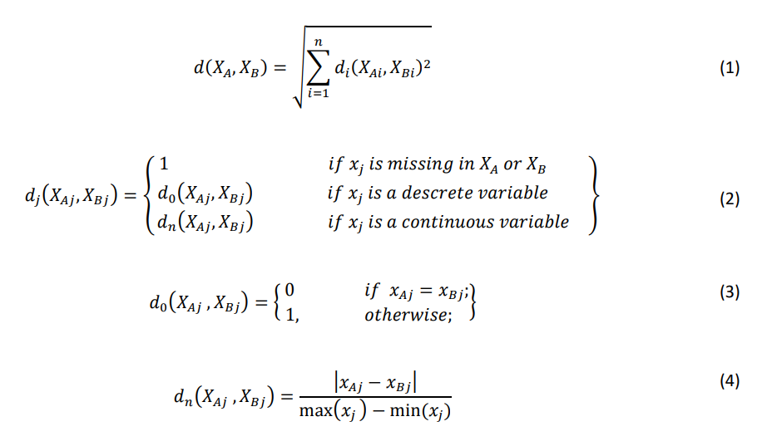

### Imputing many chained equations (MICE):

The regression model sequence runs on chained equations (MICE) or Fully Conditions (FCS) in multiple imputations, each variable without data modelling and other variables conditioned in data. A variable-per-variable imputation model has many criteria (van Buuren and Groothuis-Oudshoorn, 2011). The MICE process may handle binary, continuous and ordinary mixed information. The technique may be summed up in five steps (Azur et al., 2011).

* **Step 1:** Simple imputation approaches such as mean and mode imputations begin the imputation. The "placeholder" values should be the initial imputed values.
* **Step 2:** The variable named "var" lacks its imported values, for example.
* **Step 3:** The variable "var" values in step 2 are then returned to other variables in the imputation model. "var" is the dependent regression model variable. This regression model functions similarly to those outside the setting of an imputation.
* **Step 4:** The missing "var" values will be substituted by the regression model predictions. The predictions are based on the distribution of the Monte Carlo Markov Chain technique (MCMC). Finally, for additional variables in the regression model, "var" is employed as an independent variable.
* **Step 5:** Each variable with incomplete data is repeated with steps 2-4. If this method is entered many times, a collection of data is sent. The coefficients of the regression model tend to remain stable with enough iterations. This m-time contains multiple imputed data sets. Usually, 10 repeats with up to 40 data sets are sufficient to converge (Graham et al., 2007). The data sets are then examined and combined by a medium or a majority vote. Figure 1 displays a process representation with m = 3.

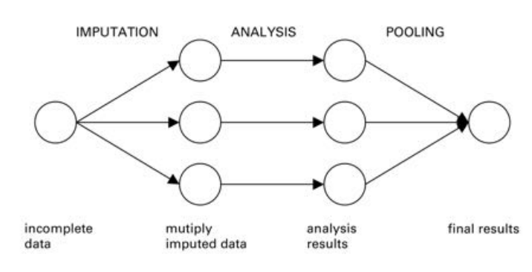

Figure 1 - [Multiple imputations by Chained Equations scheme.](https://www.google.com/url?sa=i&url=https%3A%2F%2Fwww.researchgate.net%2Ffigure%2FMain-steps-used-in-multiple-imputation_fig1_44203418&psig=AOvVaw0ILpAzTcoc36X8oiYN1wrU&ust=1623075568108000&source=images&cd=vfe&ved=0CA0QjhxqFwoTCPDFm-iZg_ECFQAAAAAdAAAAABAD)

### MissForest:

MissForest is a mixed-type non-parametric imputation method. It is an iterative imputation strategy based on random forest formation. Interesting is the calculating efficiency and the capacity of this methodology. Data management in higher dimensions (Stekhoven and Bühlmann, 2012b). Stekhoven & Buhlmann (2012) have introduced this imputation methodology to build a system that can handle data entries at any time and assumptions as little as possible. Studies by Stekhoven et al. (2012) reveal that, independently of type composition, dimension of data and missing value quantities, the methodology rivals or outperforms various common imputation strategies. It is difficult to express data sets comprising intricate interactions and non-linear linkages using parametric processes. Parametric approaches need to be tweaked using a parameter. Without prior knowledge, picking parameters is tricky and might dramatically impair the performance of techniques. Since MissForest does not presume data, these complex linkages and non-linear interactions might better be recorded. Like MICE, a middle-mode imputation is used for estimating outcomes, random forests are trained on values observed and continue to anticipate missing values until a stop is reached. Because the approach averages various untapped trees, MissForest may be seen as a multiple imputation strategy.

Just like MICE. Just like MICE. Just like MICE. Just like MICE. Imputation errors without the test set requirement may be expected at OOB error rates. The discrepancies between OOB and actual error rates often do not surpass 10-15 per cent, Stekhoven et al. (2012) said. Random forests are finally built on decision-making trees, and decision-making trees are sensitive to class imbalances, so will MissForest. However, this might be considerably eased by assigning class weights before imputation (FAMD).

Factorial Mixed Data Analysis (FAMD):

Factorial Mixed Data Analysis (FAMD) is the ultimate imputation methodology (Audigier, 2016b). It is a vital component to load missing data values. It explores the similarities between persons and the relationships among factors since it is based on the main component methodology. If a mixed data matrix is provided, the categories are turned into dumb variables (called a matrix for the indicator). The centre of each continuous variable is then broken down by its standard deviation (also called standardization). The dummy variables are divided by the square root of the proportion of persons in the category concerned. The missing numerals are first charged with the medium. The principal component analysis (PCA) will be performed on the matrix, again and again, using a single decomposition value (SVD). The FAMD imputation on a range of data sets compare Audiger et al. (2016) to MissForest (Stekhoven and Bühlmann 2012b). They show that FAMD surpasses MissForest if the continuous variables are strongly linear. Furthermore, FAMD's NRMSE only increases somewhat as the per cent of missing data grows, whereas MissForest's NRMSE climbs significantly. Finally, MissForest works better in severe nonlinear interactions between variables, but only modestly. Their research shows that FAMD is still a competitive imputation strategy in all cases.

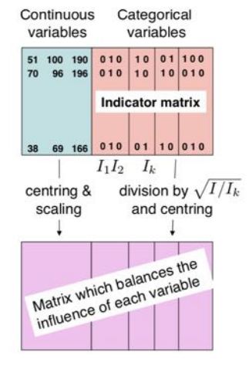

Figure 2 - FAMD method (Josse and Husson, 2016)

### The technique of synthetic minority over-sampling (SMOTE):

SMOTE in this investigation is another kind of data level (Chawla et al., 2002). Machine learning techniques are generally designed to boost accuracy via error reduction (Chawla, Japonica and Drive, 2004). Most do not analyse the distribution of classes. Over-sampling or under-sampling may be carried out. Sub-sampling Indicates removal of a class bulk to balance data collection. Oversampling is the generation of additional minority class points for balancing the dataset. This can be done altered by the replication of minority classes, but it risks being overdone. Chawla et al. (2002) suggested SMOTE for over-sampling and reduction of the danger of overfitting. SMOTE creates synthetic dots by randomly selecting a minority sample and then selecting one of its closest neighbours. Send 0 to 1 and add the total to the minority sample, increasing the difference between the closest neighbour and the minority sample. This lowers the overfitting potential since synthetic samples are produced and repeated not just between the minority sample and its vicinity.

### Synthetic overview:

based on group Synthetic over-sampling is a method of SMOTE over-sampling. The data is grouped with enough clusters using any clustering approach (Kanungo et al. 2000). The appropriate number of clusters may be determined using approaches like statistics on gaps or average silhouettes (Rousseeuw, 1987). The average K-value observation calculates the average K-value. The optimum number of clusters optimizes the average silhouette by taking into consideration a range of k values. The statistics of Gap are another way to identify the ideal number of clusters. It seeks to maximize cluster variation (Tibshirani, Walther and Hastie, 2001). However, our analysis does not mainly concentrate on clustering, since we indicate the origins. Santos et al. (2015) utilized K = 10 in their researches to analyses K values of 2 to 30 ranges.

Once the data is categorized, minority clusters are sampled. These are the clusters having the lowest sample number. Then SMOTE is employed, however with various modifications. The random SMOTE number (0 to 1) is used to choose the label of the synthetic sample class when over-sampled. The synthetic point is given a specified class name if the value is less than 0.5. If it is bigger than 0.5, the other class label is appended to the sample. The assumption, of course, is that under these circumstances there are only two classes.

# Aims and Objective:

The point here is making an AI that gives recuperation or substitution to any absent or conflicting information in an individual dataset. The dataset utilized will be of the clinical area. The accompanying advances when followed will help accomplish this point:

* Writing survey of the work done by specialists in a similar area to learn of the mainstream calculations utilized for information attribution.
* Dataset determination and information pre-preparing. In any case, during the time spent pre-handling, the missing qualities won't be prepared since that will be finished by the calculation.
* Planning the Machine Learning Algorithm. The dataset measurements will be noticed and the appropriate calculation will be utilized to decide the missing qualities in the information. The worldview for this Machine Learning Research Project will be Regression. Along these lines, Regression calculations like SVM Regressor, MLP Regressor, ARIMA and Multivariate Linear Regression calculations will be utilized for this reason. These calculations will be accessible from the scikit-learn library for Python.
* Execution Metrics for the Algorithms. Since exactness can't be determined for Regression calculations, their presentation must be estimated as a blunder in its forecasts. To quantify these blunders, the accompanying ways are utilized:

|  |  |
| --- | --- |
| Performance Metric | Formula |
| Mean Squared Error (MSE) | If **n** predictions are produced from a dataset with **n** data instances; where **Y** is the vector of labels in the dataset and is the vector of predicted labels, then |
| Root Mean Squared Error (RMSE) |  |
| Mean Absolute Error (MAE) |  |

## Research Questions

The following questions provide the direction to this project:

1. Can AI give the help required in battling the issue of missing information occasions?

## Ethical Considerations

The UK Data Service division also offers rules to moral investigation with express association with Big Data. These standards will outline the justification of this current report's ethical philosophy. The focuses that should be centred around are:

* Keeping information confidential that ignores pack insurance,
* Alluding to focal points for all information used inside the assessment project,
* Ensuring all data is taken care of in the correct territory.

# Literature Review

The measure of missing values gives some insight into how much the missing qualities influence the outcomes, as it is identified with its effect on research ends (Bengtsson and Lindblad, 2020). For the most part, bigger extents of missing qualities will in general greatly affect factual surmising and generalizability since it shows that more data about the populace is missing (Bengtsson and Lindblad, 2020). The example information may mirror an inclination as a great deal of noticed information gets erased because of a ton of perceptions acquiring missing qualities, prompting one-sided boundary appraises and misdirecting measurable derivation (Bengtsson and Lindblad, 2020).

This makes Literature Review, the way toward alluding to the examination done by peers in a similar area obligatory. Since there is a lot of work done in this field, a method to proceed with this is made as shown in *Figure 3*.

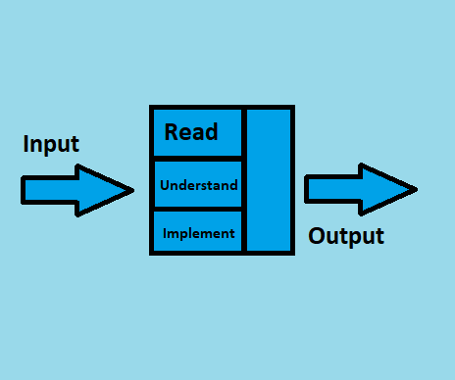

Figure 3 - Literature Review Workflow

As insinuated above, work is being done on this point for a long time back. In this time, a huge load of the review material, expressly assessment papers have amassed for anyone that necessities to do a Literature Review. In any case, examining the total of the papers now isn't possible. Thusly, a course of action for picking quality papers needs to be in place. The technique is according to the going with:

* English ought to be the lone language in the papers.
* Should be spread in diaries with a high effect factor.
* Complete and free access should be accessible for the Paper and the Journal.
* All the evaluation datasets and code for the papers should be open.
* 10 years old assessment isn't allowed.

The papers chosen to concentrate on in this examination are talked about in this segment. The technique/tests led in these examination papers and the outcomes that those trials bore will be the primary focal point of this segment. Missing data is the most notable issue experienced by AI subject matter experts while analysing genuine data. In various applications going from quality verbalization in computational science to examine responses in humanistic systems, missing data is accessible to various degrees (Bertsimas, Pawlowski and Daisy Zhuo, 2018). As various quantifiable models and AI estimations rely upon complete enlightening records, it is crucial to managing the missing data appropriately. Here and there, fundamental philosophies may get the job done to manage missing data. For example, a total case assessment uses simply the data that is known and blocks all insights with missing characteristics to prompt a verifiable assessment (Bertsimas, Pawlowski and Daisy Zhuo, 2018).

These capacities commendably two or three discernments contain missing characteristics, and when the data is missing absolutely at sporadic, complete case assessment doesn't expeditious uneven outcomes (Bertsimas, Pawlowski and Daisy Zhuo, 2018). On the other hand, a couple of AI estimations ordinarily address missing data, and there is no necessity for pre-taking care of it. For instance, CART and K-infers have been adapted to issues with missing data. In various conditions, missing characteristics ought to be ascribed to going before running quantifiable assessments on the absolute educational file (Bertsimas, Pawlowski and Daisy Zhuo, 2018).

Analysts have been chipping away at this issue for some time before and have concocted creative, new and novel ways to deal with taking care of Data Imputation. The Literature Review for this exploration centres on ways to deal with Data Imputation after 2014. The methodologies for Data Imputation are for the most part measurable, yet as of late more inventive and novel methodologies are showing up in the Literature i.e., profound learning, generative antagonistic learning, fluffy rationale, Autoencoders and some more.

Missing data is ubiquitous in gigantic data clinical starters. Through various assessments don't unequivocally report how they handle missing data; some evident procedures are used in quantifiable programming. In this manner, different packs may surprisingly manage missing data (or the default systems are extraordinary) and results may not be duplicated decisively by using assorted quantifiable programming groups (Zhang, 2016). Sometimes, this may not prompt on a very basic level different results, yet the consistent sufficiency of the examination is sabotaged. The best practice is to explicitly state how missing characteristics are dealt with. For ease, various experts eradicate insufficient cases (Listwise exclusion), which is similarly the default procedure in various backslide packs (Zhang, 2016).

This methodology gets trustworthy results exactly when the number of missing characteristics isn't huge and the missing model is missing unpredictably (MCAR) or missing MAR. Another insult to complete case assessment is information adversity. This can be a significant issue when there is a gigantic number of components (sections) (Zhang, 2016). A liberal number of cases can be deleted because abrogation relies upon missing values on at any rate one element. Additionally, a total case examination can incite unpredictable tendencies (Zhang, 2016). The response to this issue is attribution. Missing characteristics are displaced by attributed values. Since credit is a space of dynamic assessment, there are different strategies and groups made for attribution (Zhang, 2016).

The missing qualities are generally assessed utilizing focal inclination estimates like mean, middle and mode in numerous sorts of exploration (Zhang, 2016). The mean and standard deviation are uneven. Attributions with mode and centre work along these lines and they are left to clients for preparing (Zhang, 2016). But unforgiving attribution gives speedy and fundamental procedures to missing characteristics, it puts down change, deals with the association among variables, and tendencies summary experiences. Thus, cruel attributions should be used when an unobtrusive pack of characteristics are missing, they are not for general use (Zhang, 2016).

A few specialists use Listwise Deletion, Predictive Mean Matching and Poisson Imputation for handling the information ascription issue (Bengtsson and Lindblad, 2021). The outcomes for these strategies from the paper by (Bengtsson and Lindblad, 2021) are as per the following:

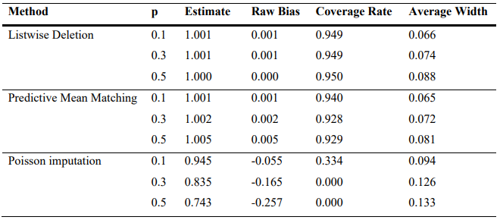

Figure 4 - Randomized Data Imputation Results from Listwise Deletion, PMM and Poisson Imputation

Attributions utilizing Central Tendency measures are mainstream among specialists in this area. Different methodologies like the Predictive Mean coordinating with Discussed above is additionally famous among scientists. Respectably utilized methodologies for Data Imputation additionally incorporate Imputing utilizing bunching strategies like k-NN, attributing utilizing probabilistic techniques like the Bayes hypothesis and conventional relapse calculations like the Linear relapse. Aftereffects of these calculations from the exploration done by (Jadhav, Pramod and Ramanathan, 2019) are as per the following:

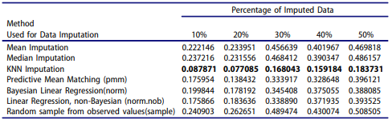

Figure 5 - Results of the Wine Dataset

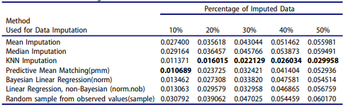

Figure 6 - Results on the Glass Dataset

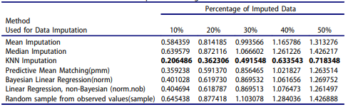

Figure 7 - Results of the Concrete Compressive Strength Dataset

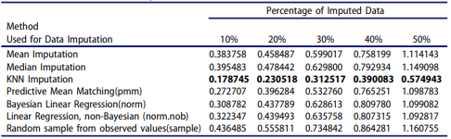

Figure 8 - Results of the Liver Patient Dataset

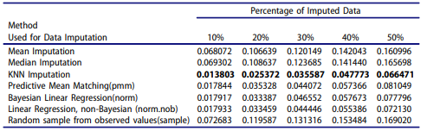

Figure 9 - Results on the Seeds Dataset

The outcomes from these investigations demonstrate the legitimacy and the strength of these methodologies. It demonstrates why these methodologies are so mainstream and more than once utilized in this space. Albeit the methodology isn't the solitary factor influencing the outcomes. The execution of the methodology on chose datasets likewise matters a ton. That is the reason (Jadhav, Pramod and Ramanathan, 2019) utilized five datasets to demonstrate the strength of the exhibition of different well known Data Imputation strategies.

**Imputation techniques:**

A total of four distinct techniques of imputation were used. Multiple Chained Equations Imputations for further details on how each approach works (MICE) As described in section 2.4.3. MICE is a regression model sampling technique provided for each variable. All binary variables have been treated using logistic regression, the normal data has been treated with an ordered logit model. The continuous data were either modelled on a normal distribution or a predictive mean match. A Q-Q plot was developed in R to determine whether or not a variable was normally distributed. If the Q-Q track is about y = x, normalcy is a plausible assumption. If not, predictive mean matching (PMM) has been utilised. A total of 40 MICE data sets have been imputed. To be clearer, the HCC dataset was imputed 40 times, resulting in 40 separate "whole" datasets. Figure 24 exhibits Q-Q plots, one of which is regularly distributed, and one of which cannot be considered to be normal. The variable regularly distributed is the mean corpuscular volume. The usually not distributed variable in Figure 23 is alanine transaminase.

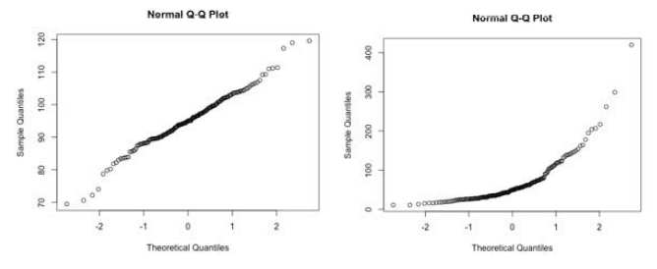

*Figure 24 - Normal Q-Q plots. Left: Since the points lie roughly on the y = x line, normality is a reasonable assumption.*

**K-NN Imputation:**

HEOM was employed as a distance measure for K-nearest neighbour imputation with K = 1. The main rationale for selecting K = 1 was to reproduce the identical settings utilised by Santos et al (2015). (2015). (2015). Since K-NN imputation always yields the same values, just one full data set was given to this approach.

**MissForest:**

MissForest is the name of the imputation technique employing Stekhoven et al's Random Forest (2012b) (2012b) (2012b). It was implemented in R using Stekhoven et al's prepared package (2012b) (2012b) (2012b). The HCC dataset has been imputed 40 times per initialization using 100 trees, producing a total of 40 "finished" datasets.

**Mixed Data Factorial Analysis (FAMD):**

The iterative FAMD technique, like the K-NN imputation, always returns the same imputed values. Only one "full" dataset has thus been imputed using the R miss MDA tool.

**Transformation of Z-score:**

As it was done by (Santos et al., 2015). With the Z-Score transformation, each column was modified to have a mean of 0 and a standard deviation of 1. This was an essential step in the subsequent application of K-means. Because the only categorical variables in the HCC dataset are binary or normal, Z-Score transformation was not an issue.

**K means, K-means++ and silhouette and oversampling on a cluster basis:**

The data sets imputed were grouped using K-means with initialised K-means+. The number of clusters k was selected as k = 7. The number of clusters was based on the figure and the difference between clusters. Dissimilarity and silhouette for all k values between 2 and 30 have been determined. A higher figure and a greater discrepancy are regarded as favourable. Once the number of clusters has been established, there have been a total of 20 K-mean initializations. There were varied cluster sizes with each initialization. With every initialization, SMOTE exaggerated the little clusters to the same size as the biggest cluster. This was performed until all the clusters were identical in size. When this was done, 20 per cent of the items were randomly selected and added to a single big representative data set in each initialization. This has been replicated for all the data sets alleged. This technique has been done 40 times over for K-NN and FAMD since it always produced the same alleged results. The typical data sets included anywhere between 1100-1400 data points, depending on the sizes of the greatest clusters.

**Support Vector Machine Parameters:**

Once representative data sets were developed, the Caret package was used to train a Vector Support Machine using an RBF kernel. The values which were examined and assessed by a 50-fold cross validation were: C: [0.1, 1.0, 1.5, 2.0, 2.5, 3.0, 4.0, 4.0, 6.0, 7.0, 8.0, 9.0, ......, 128] b: [0.001, 0.01, 0.1, 1 .0] .0] .0]

These settings were selected based on an initial run and offered the greatest precision. Smaller numbers and higher values only yielded poorer outcomes than those above. The value k=50 was set to be as big as possible during k-fold cross validation while making it computationally practical.

**Assessment methods and statistical tests:**

Three separate assessment measures have been employed. Precision, F-measurement and AUC. Each statistic was examined for its mean and standard deviations. Each is discussed in the following sections. Once all the essential assessment measures have been taken, the data have been evaluated using single-way ANOVA (Variance Analysis) coupled with the honest significance test from Tukey.

**Accuracy:**

In the assessment of machine learning algorithms, the confusion matrix in Table 3 is often utilised (Chawla et al., 2002). (Chawla et al., 2002). (Chawla et al., 2002). TN is the number of samples that have been classed as negative. FN is the number of samples that in actuality are positive but mistakenly categorised as negative. TP is the number of samples that are positive and categorised as such. And FP is incorrectly categorised as positive the number of negatives.

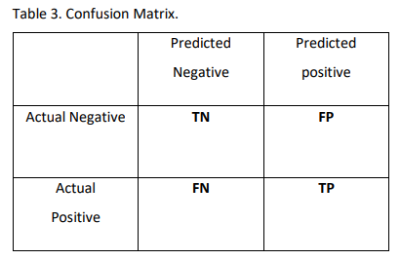

Accuracy in the performance assessment of machine learning algorithms is fairly prevalent. This is the per cent of samples that are properly categorised among all samples. This is an easy technique to measure the performance of models but is quite sensitive to data changes. Chawla et al. (2002) give an example where the data is skewed. In the example, 98 per cent of the data are in the main class, therefore if the classifier consistently thinks that the majority class is 98 per cent accurate. This is why accuracy is not enough when data are unbalanced, but is nevertheless included in comparison to the prior research. Precision is defined as:

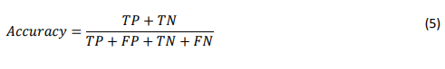

**F-measurement:**

F-measure is both precise and reminder (Sasaki, 2007; Powers, 2011). The accuracy is the fraction of categorized positive accurately between all samples classified as positive. The recall is the fraction of all really good elements labelled as such. Accuracy and reminder are characterised as:

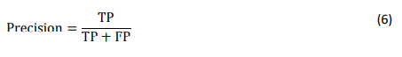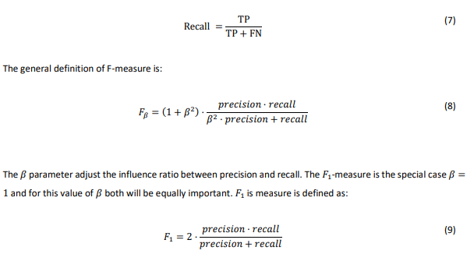

# Project Timeline



Figure 10 - Project Timeline

# Project overview and Methodology:

Machine learning algorithms 2.3.1 Maximum classifications of margins, soft margins and support of vectors A classification of maximal margins (Tibshirani et al. 2007) is a classification based on an overhead plane dividing classes into one Input variable space. Such a hyperplane is a two-dimensional line. The hyperplane would be a three-dimensional flat surface. A linear equation that provides a scalar output to solve a binary classification problem classifies everyone above the hyperplane as one class and belongs to the other. The sign of the output provided by the linear equation may determine this. This approach may be used to distinguish points regardless of dimensionality. While the courses are linear. However, in theory, there are a limitless number of hyperplanes if the classes are linear. These hyperplanes (lines) are shown. The obvious way to choose the best hyperplane is to choose the furthest hyperplane from sightseeing. This implies that the hyperplane is selected which is perpendicular to the training observations of both sides. This is called the margin. Figure 11 shows the line with the largest margin on the right. The training observations closest to the hyperplane are called vectors of support because they choose the hyperplane position. A new observation may dramatically change the direction of the hyperplane – hence a soft margin is best used. A soft margin means we might misclassify some data to better categorise the remaining data. This improves the categorization of outliers.

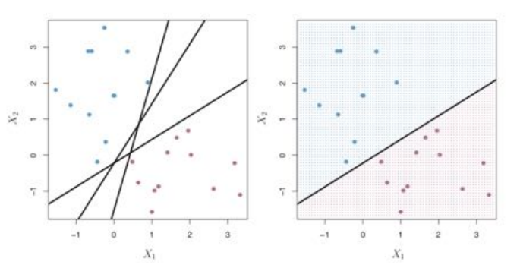

Figure 11 - Left-hand side shows possible separating hyperplanes. The right-hand side shows the hyperplane with maximal margin. (James et al., 2000)

Finally, SVM's are a typical classifier option that extends the classification of Toshigami and the soft margin (2007). In conditions wherein a specific space is not linearly separable, a technique is required to separate the class. The SVM maps the original input space of the kernel.

In a much broader territory, the differentiation in this area is simplified. The kernel approach involves the usage of vector points and the summing of the kernel. Depending on the kernel used, the decision limit may be made non-linear. Figure 12 shows the choices for a polynomial kernel (left) and a radial function for a Russian kernel (right-hand side).

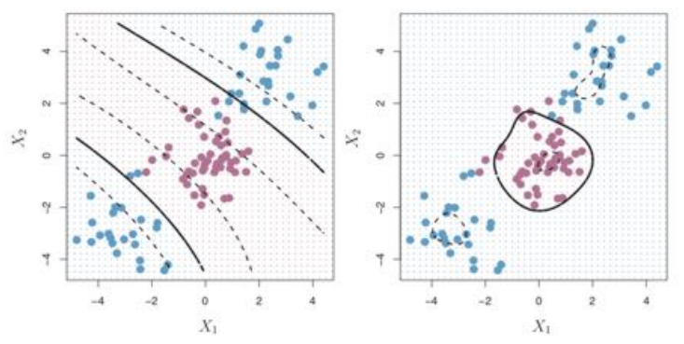

Figure 12 - Left-hand side: Decision boundary with a polynomial kernel. Right-hand side: Decision boundary. (James et al., 2000)

## Previous comparative outcomes of study and imputation:

There is little literature on the imputation of mixed data. In this section, we will offer some significant results. Two comparative studies employing imputation methods. The first is Stekhoven & Buhlmann's study (2012). As mentioned above, the misForest Random Forest imputation approach is designed to produce a system that is capable of handling any data and makes minimal premises.

Stekhoven et al. (2012) say that the technique is competitive or exceeds various standard imputation approaches irrespective of type, size and value. Figure 13 illustrates three separate NRMSE/PFC imputation approaches: KNN, MICE and MissForest based on four distinct data sets and three distinct quantities are not available.

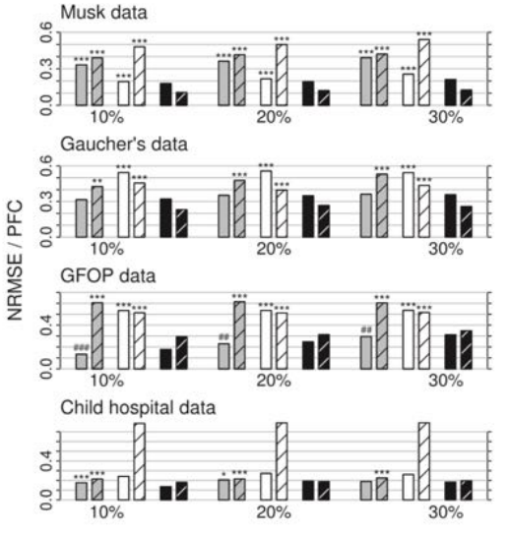

Figure 13 - Mixed-type data. Average NRMSE (left bar) and PFC (right bar), for KNN-Imputation (grey), MICE (white) and missForest(black). On four different datasets and three different amounts of missingness. (Stekhoven and Bühlmann, 2012)

Table 1 shows the average runtime for each approach and data set. As shown in Table 1, misForest is quicker than the K-NN imputation, nevertheless, MICE work in any data set. The research by Stekhoven et al. is the cause for this to develop innovative ways of imputation.

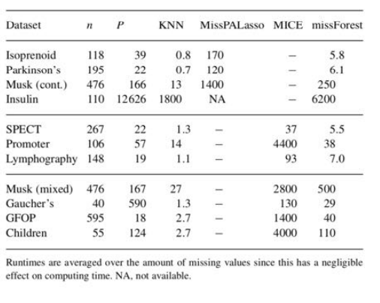

Figure 14 - Average runtimes (in seconds) for imputing the datasets analyzed by (Stekhoven and Bühlmann, 2012)

Stekhoven et al. (2012b) conclude that misForest enables any kind of data to be charged for lack of value. It can concurrently handle categorical and continuous data and goes beyond typical imputation approaches like K-NN and MICE (Multiple Imputations by Chained Equations). Second comparative investigation Check and al (2013). Create a primary component method to compute the missing mixed data values. Section 2.2.4 explores in more detail the methods (FAMD). The comparison between Audiger et al. (2013) and MisForest is relevant for data sets, where variables are linearly connected to nonlinear correlations between them for data sets. The figure displays the missForest and FAMD NRMSE and PFC values. As may be noticed, FAMD values (errors) are lower than MissForest values. In addition, errors in the FAMD process grow slightly as the percentage of missing data grows and the misForest error greatly increases. Audiger et al. (2013) demonstrate that these conclusions are consistent with all sets of data having a linear connection.

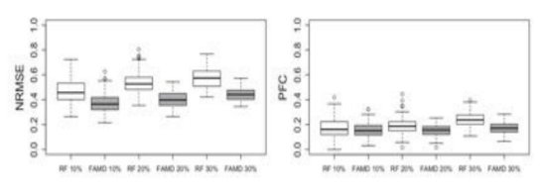

Figure 15 - Distribution of the NRMSE (left) and the PFC (right) when the relationships between variables are linear for different amounts of missing values (10, 20, 30 %). White boxplots correspond to the imputation error for the algorithm based on random forest. (Audigier, Husson and Josse, 2013)

If these datasets contain considerable non-linear links or significant interactions between categorical variables, missForest goes beyond the iterative method to FAMD. This is seen in the figure. Based on these findings, Audiger et al (2013) concluded that FAMD is a better data collection imputation approach.

With linear interactions inter-variable. The Random Forest (MissForest) works effectively if significant interactions between non-linear or categorical variables occur. The united research team Stekhoven et al. (2012b) and Audiger et al. (2013) provides the foundation for the importance, value and impact of imputation procedures on classifiers, including SVMs.

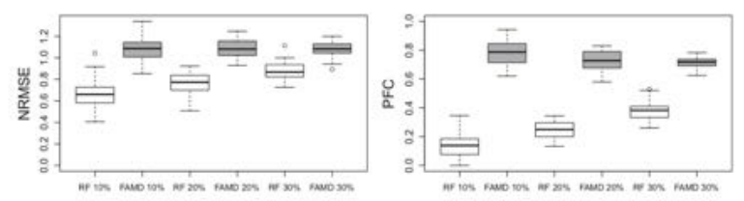

Figure 16 - Distribution of the NRMSE (left) and the PFC (right) when there are interactions between variables. (Audigier, Husson and Josse, 2013)

Results are given for different amounts of missing values (10, 20, 30 %). White boxplots correspond to the imputation error for the algorithm based on random forest (RF) and grey boxplots to the imputation error for iterative FAMD.

## Classification impact of missing data imputation strategies:

Previous work on missing data-focused largely on comparing and analyzing various imputation strategies using metrics such as standard root medium-square errors. CMRN. Not much research was carried out in a more practical approach to examine the implications of imputation approaches. Souto et al (2015) conducted done investigation on the discrimination/predictive power of categorization approaches for gene expression. Souto et al (2015) noted that while evident changes in the imputative performance evaluation using measures such as NRMSE and PFC may exist, there may be no significant differences in categorization impacts. They find the modest influence of imputation approaches on classification and clustering approaches. Among the K-NN imputations, several 12 data sets of Bayesian Main Component Analysis (PCA) gene expression supported by vector regression has been evaluated (SVR). Souto et al (2015) research are essential as it emphasizes that while some imputation processes appear persuasive to override others, the difference in categorization and grouping may up modest.

# Experimentation:

The experimental design of the project is divided into three different parts i.e., the data preprocessing, statistical method selection for data imputation and the Machine Learning algorithm implementation. To this extent, a dataset must first be finalized. This project aims to show the prowess of Machine learning and statistics for Data imputation. Since the dataset will serve no other purpose in this research other than being a playground for experimentation, a toy dataset specifically meant for data imputation is selected.

## Dataset

The Titanic dataset is very popular amongst researchers that require a playground for testing and benchmarking their Data imputation techniques. The titanic dataset comes split into a training set with 890 data instances and the test set with 420 data instances for a total of 1310 data instances in the complete dataset. The features in the dataset are as follows:

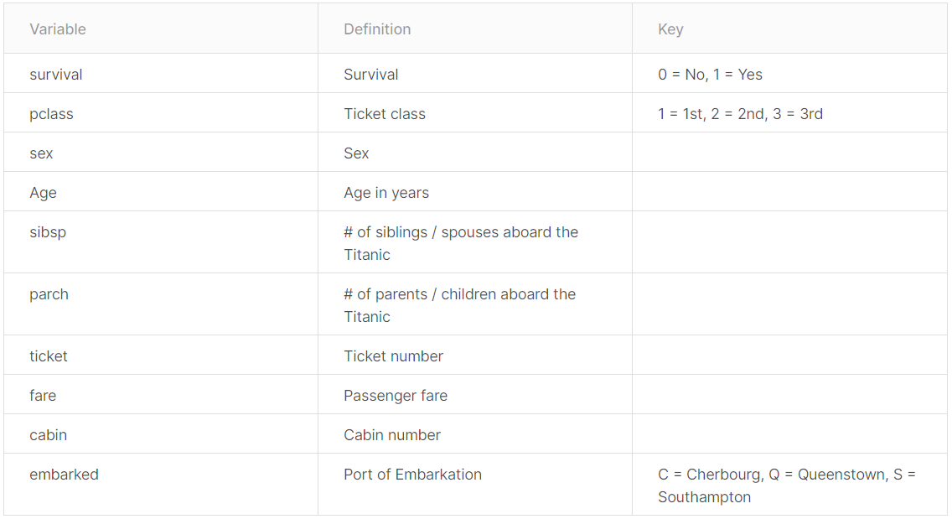

*Figure 17 - Dataset Features and their Description*

The dataset is finalized; therefore, the next step is to check the data for missing values since this project aims to impute those. Upon the analysis of both the datasets, it can be seen that there are missing values in two features of the datasets, i.e., “Age” and “Cabin”.

## Data Preprocessing and Visualization

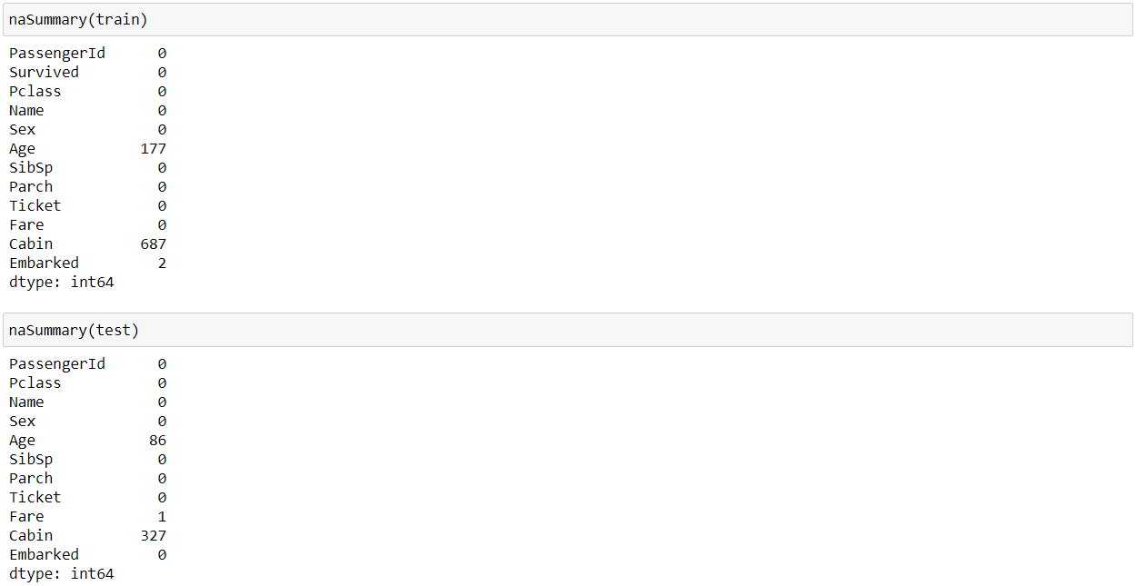

*Figure 18 - The number of missing values in "Age" and "Cabin" in both datasets.*

From Figure 18, it tends to be seen that the number missing qualities just exist in two of the highlights in the datasets i.e., "Age" and "Cabin". The level of missing qualities for "age" in the preparation dataset is 19.88% and 77.19% for "Cabin". The equivalent is the situation with the test dataset. The solitary highlights with missing qualities in the test dataset are the "age" and "Cabin" includes separately. The level of missing qualities for "age" in the test dataset is 20.47% while the level of missing qualities in "Cabin" in the test set equivalents is 77.85%. This suggests that the grouping of this examination will be the ascription of missing information in these two segments.

The information representation for the datasets is done independently for each element. Since the dataset is a toy dataset for information attribution, no measurable outcomes that give observational and graphical examination have been finished. The lone information perception done is the examination of the likelihood dissemination of the highlights in both datasets.

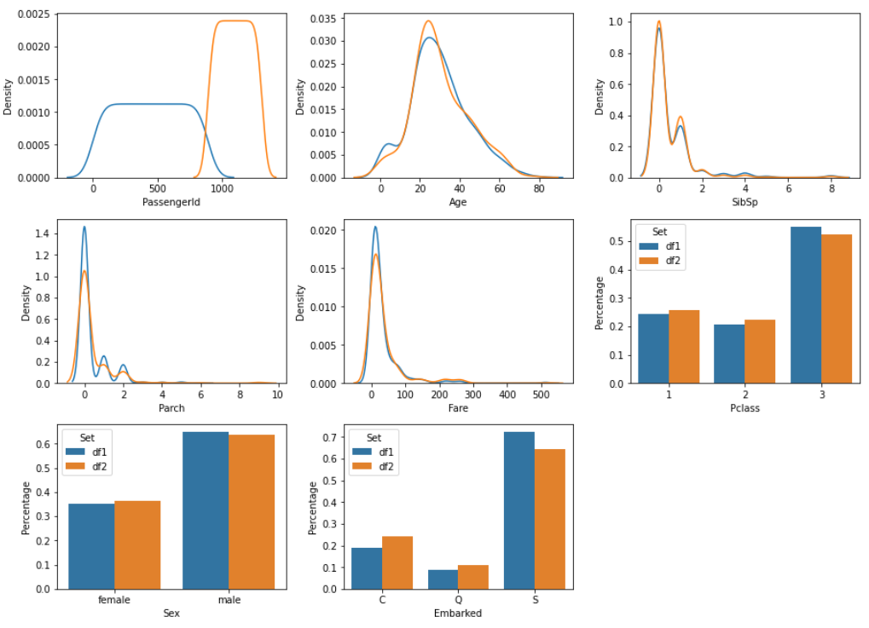

*Figure 19 - Probability Distribution comparison for features in the training and test datasets.*

Figure 19 shows the dispersion correlation for every one of the highlights in the preparation and the test datasets. The blue diagrams in the Figure address the preparation datasets and the orange address the test dataset. One perception that can be made in regards to the dispersion correlation in Figure 19 is that the "Endurance" variable is absent from the examination. The explanation for the variable missing is the way that the element "Endurance" is an element with paired yield i.e., 0 and 1 as demonstrated in Figure 10. Because of this, an appropriation examination for this element won't be conceivable. Another surmising that can be produced using the perception of Figure 19 is the way that every one of the highlights in both datasets has practically the same and practically consistent likelihood dispersions.

The missing qualities for the "Cabin" variable are handled. The task means to show that Machine Learning can be a compelling instrument in taking care of the ascription of information esteems in datasets with missing qualities. To this degree, just one of the highlights specifically "Age" will be exposed to information ascription strategies utilizing Machine Learning. The information occasions where the information in "Cabin" is missing will be disposed of. The code bit in Figure 20 shows that even after the dropping of examples that had invalid qualities for "Cabin", the number of invalid occasions in "Age" didn't change.

The circulation correlation is made again by the creator to see how the dissemination of the highlights across both datasets has changed in the wake of diminishing the number of occasions in the dataset. The new appropriation correlation between the highlights of the preparation and test sets have appeared in Figure 20.

. 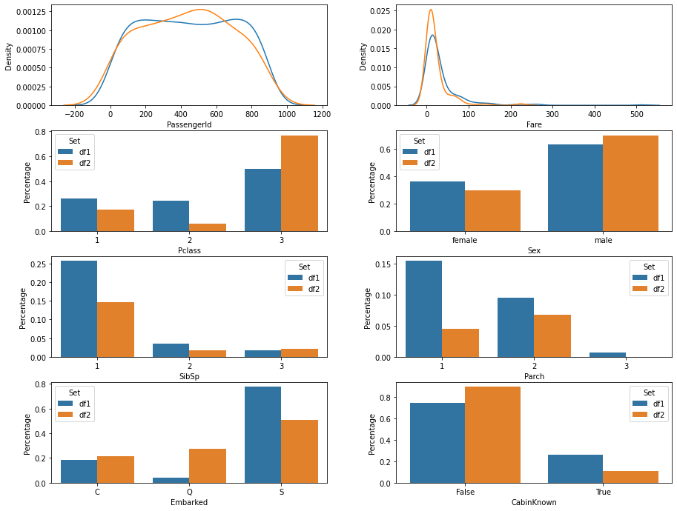

*Figure 20 - New Probability Distribution comparison for features in the training and test datasets.*

## Machine Learning

The essential information representation and information preprocessing are done and the datasets are presently prepared for the utilization of different attribution strategies. The perception of the dataset shows us that the dataset contains highlights with various yield classes. Since the dataset characterizes the sort of calculation to be utilized in a Machine Learning project, the calculation utilized for this undertaking will be from the characterization domain of Machine Learning, i.e., the Random Forest Classifier. The calculation will be utilized to describe the dataset utilizing three distinctive measurable strategies applied to the dataset before the interaction of ascription.

The AI calculation and the factual strategies will be clarified exhaustively before plunging into the execution and the aftereffects of the Machine Learning and Statistics blend. The Random Forest Classifier is not the algorithm used for data imputation in this research. This classification algorithm is used as a performance metric in this research. Data will be imputed using three different techniques and will be given to the Random Forest Classifier. The accuracy of the Random Forest Classifier for each of the Imputed data versions will be the benchmark that will decide which technique for data imputation performs the best comparatively.

## Results

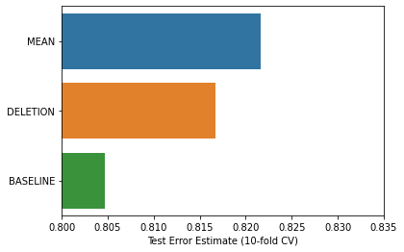

*Figure 21 - Results for the Classification for each of the Imputed Data.*

The aftereffects of the investigation are shown graphically in Figure 21. The mean imputation played out the best followed by deletion, then, at that point comes the baseline at the last. The method used for algorithm evaluation was 10-fold cross validation.

The perception that can be produced using the outcomes diagram in Figure 21 is that even though the number of occurrences was more in the standard technique and less in the cancellation strategy by an enormous edge, the distinction in the outcomes between them is shocking. This measure of distinction was unforeseen. This demonstrates the way that the sheer number of examples and the gigantic size of information doesn't make any difference if there is no quality in the dataset.

# Conclusion and Discussion:

The significance of Data ascription increments with the increment in information. The expansion in information has been dramatic. It is not, at this point a human accomplishment to gather and oversee information. Information assortment is being computerized. Thusly, the subsequent datasets may contain blames or may have an instance of missing qualities. This examination centres on taking care of this issue utilizing the relapse worldview in Machine Learning Titanic dataset. Based on the findings, we infer that the imputation technique selection influences categorization. Statistical tests show that the Baseline procedure, where the missing values are just deleted from the dataset was lower than all other techniques. The causes are described in the following section.

The allocation of forest and FAMD was not statistically significant. This is interesting since one of our hypotheses is that this improves the charging of data and hence offers a more representative data set to support the vector to better capture the relationships behind it. Another topic of research was whether Santos etc. had picked the K-NN imputation adequately (2015). The findings demonstrate that the HCC dataset is used both for K-NN and Random Forest (MissForest) and FAMD. We thus conclude that Santos et al. (2015)'s imputation procedure was appropriate and had no unfavourable impact on classification compared to the state-of-the-art imputation methods outlined above. Our research is nonetheless small and the findings cannot be generalized. A variety of alternative data sets and other classification procedures should be investigated at a varied speed to analyse the influence on the classification in general from missing data imputation. Section 6 addresses these limits and provides a further future inquiry.

Using Random Forest Machine Learning algorithm as a benchmark for testing imputation results is a performance metric approach that has an element of real-world testing to it. This way, real-time behaviour of the algorithm and the dataset can be observed. The results of the Random Forest were first tried on the Baseline approach to get a benchmark to compare the performances of the other imputation techniques to. Then Mean Imputation and Deletion imputation were applied to the dataset and Random Forest was used to get an accuracy reading. That accuracy reading was compared to the benchmark reading obtained to determine whether the effects of imputation were positive or negative. The final results turned out to be positive by a huge degree.

## Missing Data Imputation Applications:

The processes we design apply to many applications. One option would be to allow field staff to collect data directly by providing several alternatives during data input. For example, a list of producers to pick from might be shown to a user inputting data on a certain device. The possibilities are decided by the likelihood that manual pensioners already know the information. Supervised algorithms such as autoclasis are especially useful because 1. Tree alternatives may be anticipated, and 2. In contrast to decision-making methods, several target variables may be anticipated that must be re-learned for each target variable. Analysts may also boost the value of existing databases to comply with the missing information. This would enable the preparation of more detailed summaries and infographics using their standard instruments (under completion, as supplements). Due to its high accuracy in the prediction of the individual missing data values, the completeness of the data might be beneficial by an algorithm like C4.5 or a combination of C4.5 and Autoclasis. A third request would be to identify version data. Full record fields may be compared with the best expectations of the completion process. Analysts or other techniques may then study the outliers.

The absence of attribute values in real-life data sets is prevalent. Many patterns recognition and categorization issues. Researchers work on an acceptable remedy to the lack of value imputation that can properly enhance classification performance. Medical data are frequently not full as in many cases, certain aspects may be left blind to medical reports since they are inappropriate for a disease or when the individual supplying the information is not acceptable to record these values. We studied the performance of the machine as an imputation of lack of value. The findings are compared to middle/mode standard imputations. Experimental results demonstrate that all studied methodologies have outstripped the statistical technique focused on simplicity and precision (mean/mode).

The missing imputation process for numerous characteristics with missing values may be computationally enhanced using our proposed technique. However, we know that data cleaning is not a real-time or continuous operation in the preprocessing activity of data mining. The value imputation is once a task. This additional effort allows us to get solid data for improved categorization and assistance for decisions. It may be argued that machine learning algorithms may be the best way to calculate missing data for improved categorization results.

## Future Considerations:

Materials on mixed data imputation are rare, and literature on the impact of imputation on categorization is even scarcer. The future study suggests that several other dimension heterogeneous datasets will be investigated to address the non-use of data imputation methods in this categorization of impacts. Every heterogeneous data collection should be thorough and should not include missing data. We encourage the researchers to randomly delete data by randomly introducing missing values (MCAR) producing incomplete data sets at various missing rates, such as 10%, 15%, 20%, etc. If multiple data sets are taken into account, research would be more robust. Then we suggest the construction of classification systems that use vector support systems, neural networks and logistic regression models. This would assist establish whether a theoretical level as mentioned in section 6.2 is attained or not. The research potential that is limited by these theoretical maximums is reduced by the usage of several classifiers. Such a detailed study would be both helpful and enlightening.

# Reference:

1. Bengtsson, F. and Lindblad, K., 2021. Methods for handling missing values: A simulation study comparing imputation methods for missing values on a Poisson distributed explanatory variable. Uppsala University, [online] Available at: <https://www.diva-portal.org/smash/get/diva2:1520218/FULLTEXT01.pdf> [Accessed 5 February 2021].
2. Jadhav, A., Pramod, D. and Ramanathan, K., 2019. Comparison of Performance of Data Imputation Methods for Numeric Dataset. Applied Artificial Intelligence, 33(10), pp.913-933.
3. Jason Anastasopoulos, L. and G.Hunter, S., 2020. Fast and Robust Missing Data Imputation. researchgate.net, [online] Available at: <https://www.researchgate.net/publication/347741781_Fast_and_Robust_Missing_Data_Imputation> [Accessed 5 February 2021].
4. Jin, L., Bi, Y., Hu, C., Qu, J., Shen, S., Wang, X. and Tian, Y., 2021. A comparative study of evaluating missing value imputation methods in label-free proteomics. Scientific Reports, 11(1).
5. Zhang, Z., 2016. Missing data imputation: focusing on single imputation. Annals of Translational Medicine, [online] 4(1). Available at: <https://www.ncbi.nlm.nih.gov/pmc/articles/PMC4716933/> [Accessed 5 February 2021].
6. Amiri, M. and Jensen, R., 2016. Missing data imputation using fuzzy-rough methods. Neurocomputing, 205, pp.152-164.
7. BEAULIEU-JONES, B. and MOORE, J., 2016. MISSING DATA IMPUTATION IN THE ELECTRONIC HEALTH RECORD USING DEEPLY LEARNED AUTOENCODERS. Biocomputing 2017.
8. Bertsimas, D., Pawlowski, C. and Daisy Zhuo, Y., 2018. From Predictive Methods to Missing Data Imputation: An Optimization Approach. Journal of Machine Learning Research, pp.1-39.
9. Duan, Y., Lv, Y., Liu, Y. and Wang, F., 2016. An efficient realization of deep learning for traffic data imputation. Transportation Research Part C: Emerging Technologies, 72, pp.168-181.
10. García-Laencina, P., Abreu, P., Abreu, M. and Afonoso, N., 2015. Missing data imputation on the 5-year survival prediction of breast cancer patients with unknown discrete values. Computers in Biology and Medicine, 59, pp.125-133.
11. Li, Z., Sharaf, M., Sitbon, L., Sadiq, S., Indulska, M. and Zhou, X., 2013. A web-based approach to data imputation. World Wide Web, 17(5), pp.873-897.
12. Yoon, J., Jordon, J. and van der Schaar, M., 2018. GAIN: Missing Data Imputation using Generative Adversarial Nets. Proceedings of the 35th International Conference on Machine Learning.
13. Andonie, R. (2010) ‘Extreme data mining: Inference from small datasets’, International Journal of Computers, Communications and Control, 5(3), pp. 280–291. DOI: http://dx.doi.org/10.15837/ijccc.2010.3.2481.
14. Audigier (2016) ‘A principal components method to impute missing values for mixed data’. DOI: 10.1007/s11634-014-0195-1.
15. Audigier, V., Husson, F. and Josse, J. (2013) ‘A principal components method to impute missing values for mixed data’. DOI: 10.1007/s11634-014-0195-1.
16. Azur et al. (2011) ‘Multiple imputations by chained equations_ what is it and how does it work_ - Azur -2011 - International Journal of Methods in Psychiatric Research - Wiley Online Library. Available at: https://onlinelibrary.wiley.com/doi/full/10.1002/mpr.329.
17. Barua, S., Islam, M. M. and Murase, K. (2011) ‘A novel synthetic minority oversampling technique for imbalanced data set learning’, Lecture Notes in Computer Science (including subseries Lecture Notes in Artificial Intelligence and Lecture Notes in Bioinformatics), pp. 735–744. DOI: 10.1007/978-3-642-24958-7_85.
18. Bradley, A. P. (1997) ‘The use of the area under the ROC curve in the evaluation of machine learning algorithms, Pattern Recognition, 30(7), pp. 1145–1159. DOI: 10.1016/S0031-3203(96)00142-2.
19. Burke HB. Goodman PH. et al. (1997) ‘Artificial Neural Networks Improve the Accuracy of Cancer Survival Prediction’, Cancer, pp. 857–62.
20. van Buuren, S. and Groothuis-Oudshoorn, K. (2011) ‘Journal of Statistical Software MICE : Multivariate Imputation by Chained’, Journal of Statistical Software, 45(3). doi: 10.18637/jss.v045.i03.
21. Buuren, S. van and Oudshoorn, K. (1999) ‘Flexible multivariate imputation’, pp. 1–20. Available at: http://publications.tno.nl/publication/34618574/FW469e/buuren-1999-flexible.pdf.
22. van Buuren, S. van (2012) ‘Flexible Imputation of Missing Data Stef van Buuren’. Available at:https://books.google.se/books?hl=sv&lr=&id=M89TDSmlFoC&oi=fnd&pg=PP1&dq=van+Buuren+2012&ots=BcrQhnPwmc&sig=5qtoSUylJauVIzyaw4Wqvaa5XV4&re
23. dir_esc=y#v=onepage&q=van Buuren 2012&f=false.
24. Chawla, N. V. et al. (2002) ‘SMOTE: Synthetic minority over-sampling technique, Journal of Artificial Intelligence Research, 16, pp. 321–357. DOI: 10.1613/jair.953.
25. Chawla, N. V, Japkowicz, N. and Drive, P. (2004) ‘Editorial: Special Issue on Learning from Imbalanced Data Sets’, ACM SIGKDD Explorations Newsletter, 6(1), pp. 1–6. DOI: http://doi.acm.org/10.1145/1007730.1007733.
26. Cruz, J. A. and Wishart, D. S. (2006) ‘Applications of machine learning in cancer prediction and prognosis’, Cancer Informatics, 2, pp. 59–77. DOI: 10.1177/117693510600200030.
27. García-Laencina, P. J., Sancho-Gómez, J.-L. and Figueiras-Vidal, A. R. (2010a) ‘Pattern classification with missing data: a review, Neural Computing and Applications, pp. 263–282. DOI: 10.1007/s00521-009-0295-6.
28. García-Laencina, P. J., Sancho-Gómez, J.-L. and Figueiras-Vidal, A. R. (2010b) ‘Pattern classification with missing data: a review, Neural Computing and Applications, 19(2), pp. 263–282. DOI: 10.1007/s00521-009-0295-6.Graham, J. W. A. E. O. D. G. (2007) ‘How many imputations are needed? Some practical clarifications of multiple imputation theory’, Journal of Heart and Lung Transplantation, pp. 3213–3234. DOI: 10.1001/jamasurg.2014.1086.Feasibility.
29. Hastie, T., Tibshirani, R. and Sherlock, G. (1999) ‘Imputing missing data for gene expression arrays’, Technical Report, Division of Biostatistics, Stanford University, pp. 1–9. Available at: http://wwwstat.stanford.edu/~hastie/Papers/missing.pdf.
30. James, G. et al. (2000) An introduction to Statistical Learning, Current medicinal chemistry. DOI: 10.1007/978-1-4614-7138-7.
31. Jerez, J. M. et al. (2010) ‘Missing data imputation using statistical and machine learning methods in a real breast cancer problem’, Artificial Intelligence in Medicine, 50(2), pp. 105–115. DOI: 10.1016/j.artmed.2010.05.002.
32. Josse, J. and Husson, F. (2016) ‘missMDA: A Package for Handling Missing Values in Multivariate Data Analysis, Journal of Statistical Software, 70(1). DOI: 10.18637/js.v070.i01.
33. Kanungo, T. et al. (2000) ‘The analysis of a simple k-means clustering algorithm’, Sixteenth Annual Symposium on Computational Geometry (SCG ’00), pp. 100–109. Available at: https://dl.acm.org/citation.cfm?id=336189.
34. Kourou, K. et al. (2015) ‘Machine Learning Applications in Cancer Prognosis and Prediction’, Computational and Structural Biotechnology Journal, pp. 8–17. DOI: 10.1016/j.csbj.2014.11.005.
35. Little, R. J. et al. (2012) ‘special report, The Prevention and Treatment of Missing Data in Clinical Trials’, pp. 1355–1360.
36. Mazurowski, M. A. et al. (2008) ‘Training neural network classifiers for medical decision making: The effects of imbalanced datasets on classification performance’, Neural Networks, pp. 427–436. DOI: 10.1016/j.neunet.2007.12.031.
37. Obermeyer, Z. and Emanuel, E. J. (2016) ‘HHS Public Access’, N Engl J Med, 375(13), pp. 1216–1219. DOI: 10.1056/NEJMp1606181.Predicting.
38. Powers, D. M. W. (2011) ‘Evaluation: From Precision, Recall and F-Measure To Roc, Informedness, Markedness & Correlation’, Journal of Machine Learning Technologies, 2(1), pp. 37–63. DOI: 10.1.1.214.9232.
39. Rousseeuw, P. J. (1987) ‘Silhouettes: A graphical aid to the interpretation and validation of cluster analysis, Journal of Computational and Applied Mathematics, 20(C), pp. 53–65. DOI: 10.1016/0377-0427(87)90125-7.
40. Santos, M. S. et al. (2015) ‘A new cluster-based oversampling method for improving survival prediction of hepatocellular carcinoma patients’, Journal of Biomedical Informatics. Elsevier Inc., 58, pp. 49–59. DOI: 10.1016/j.jbi.2015.09.012.
41. Sasaki, Y. (2007) ‘The truth of the F-measure’, Teach Tutor mater, pp. 1–5. Available at: http://www.cs.odu.edu/~mukka/cs795sum09dm/Lecturenotes/Day3/F-measure-YS-26Oct07.pdf.
42. Scheffer, J. (2002) ‘Dealing With Missing Data’, PM and R, 7(9file:///C:/Users/Kevin/Documents/kex/pappers/Walid/Flexible Imputation of Missing Data-Stef van Buuren-Google Böcker.html), pp. 990–994. doi: 10.1016/j.pmrj.2015.07.011.
43. Souto, M. C. P. D., Jaskowiak, P. A. and Costa, I. G. (2015) ‘Impact of missing data imputation methods on gene expression clustering and classification’, BMC Bioinformatics, 16(1), pp. 1–9. DOI: 10.1186/s12859-015-0494-3.
44. Stekhoven, D. J. and Bühlmann, P. (2012a) ‘Missforest-Non-parametric missing value imputation for mixed-type data’, Bioinformatics, 28(1), pp. 112–118. DOI: 10.1093/bioinformatics/btr597.
45. Stekhoven, D. J. and Bühlmann, P. (2012b) ‘Missforest-Non-parametric missing value imputation for mixed-type data’, Bioinformatics, 28(1), pp. 112–118. DOI: 10.1093/bioinformatics/btr597.
46. Sterne, J. A. C., White, I. R., Carlin, J. B., Spratt, M., Royston, P., Kenward, M. G., … Carpenter, J. R. (2009) ‘Multiple imputations for missing data in epidemiological and clinical research: potential and pitfalls’, The BMJ, p. b2393. Available at: https://www.bmj.com/content/338/bmj.b2393.
47. Taylor, P. and Little, R. J. A. (2012) ‘A Test of Missing Completely at Random for Multivariate Data with Missing Values A Test of Missing Completely at Random for Multivariate Data With Missing Values’, Journal of The American Statistical Association, 83(December 2014), pp. 37–41. DOI: 10.1080/01621459.1988.10478722.
48. Tibshirani, R., Walther, G. and Hastie, T. (2001) ‘Estimating the number of clusters in a data set via the gap statistic’, Journal of the Royal Statistical Society: Series B (Statistical Methodology), 63(2), pp. 411–423. DOI: 10.1111/1467-9868.00293.
49. Wood, A., White, I. R. and Thompson, S. G. (2004) ‘Are missing outcome data adequately handled? review of published randomised controlled trials, Clinical Trials, 1, pp. 368–376. Available at: http://journals.sagepub.com/doi/pdf/10.1191/1740774504cn032oa.